Content for Review
Please review the following piece of content that has been written as part of your Content Retainer. If you would like any changes made, please use the ‘Track Changes’ option so we can see what has been updated and send the content back to us. If no changes are required, an email confirming you are happy with the content is all we need.
Type of Content – Basic Blog Post
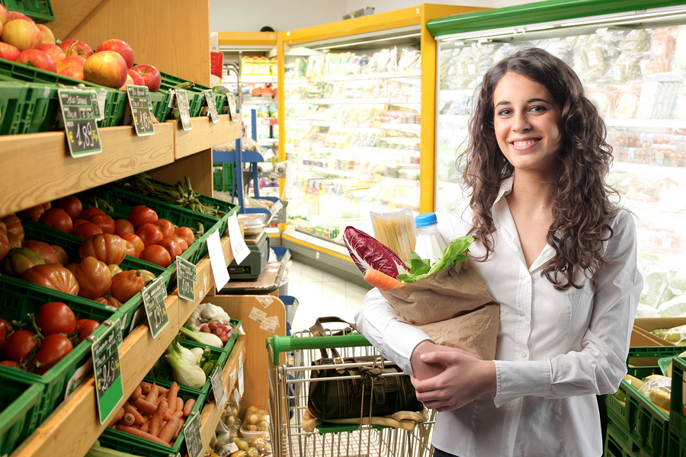

The Top 5 Health Foods To Cook With
Now we all know that fruit, vegetables and fish are among the healthiest of foods for our body, though it seems that not a great deal of us know what exactly the direct benefits are and the sort of recipes that can be cooked up using these so called ‘superfoods’.

Why Eat Superfoods?
When combined with an active lifestyle, health foods that are rich in nutrients are great for our well-being and offer a wealth of benefits that:

- Help to strengthen your immune system and protect your body from disease and illness
- Improve memory and motor functions
- Maintain energy levels
- Build stronger bones
- Keep skin and other vital organs healthy

So what are the top 5 health foods to cook with?

Avocados
If you’re a fan of Mexican food, why not make your own guacamole to add next time you’re tucking into some fajitas?
To make the perfect guacamole you will need:

- 2 ripe Avocados
- ½ a chopped onion
- ½ chopped tomato
- 1 hot chilli pepper, diced
- 1 tablespoon of lemon juice
- A pinch of salt and pepper

First cut your avocados in half and remove the seeds, then mash them in a mixing bowl with a fork until the guacamole mashed into smaller chunks.
Add the rest of your ingredients and gently mix.
Place in the refrigerator with a cling film cover to keep the air out and serve when your fajitas are ready.

Blueberries
Blueberries are a great superfood that are rich in anti-oxidants and are extremely low in fat.
We all deserve a treat every now and then and blueberry muffins are a great way to get an intake of blueberries for all the family.
You will need:

- 300g self-raising flour
- 1 tablespoon bicarbonate of soda
- 100g brown sugar
- 200g blueberries
- 260ml buttermilk
- 2 egg whites
- 5 tablespoons olive oil

Mix the flour and bicarbonate of soda in a large bowl and add your 100g of brown sugar. Place the mixture into a muffin tin.
Mix the buttermilk, oil and egg whites together until it forms a nice liquid.
Create a hole in each off the muffin mixtures and add the liquid and blueberries.
Pop them into your preheated oven at 180°C and leave for 20 minutes.
Once the time is up, remove the muffins from the oven and allow them to cool down.

Pomegranate
Like blueberries, pomegranates are full of anti-oxidants and have a wildly unique flavour. A great dish for the summertime is chicken with pomegranate salsa.
To prepare, you will require:

- 2 chicken breasts
- 4 chopped tomatoes/1 tin
- 1 red pepper, diced
- 1 pomegranate, diced

Cook up two chicken breasts in an oven for around half an hour at 190°C.
While the chicken is cooking, mix your chopped tomatoes, pepper and pomegranate seeds.
Serve over the chicken and enjoy.

Oily Fish
Oily fish like salmon, trout and mackerel are renowned for their benefits to health; packed full of omega-3 fatty acids and vitamin D that help to prevent heart disease.
Try and squeeze a meal or two of oily fish into your week; salmon with new potatoes and steamed vegetables is a fantastic choice.
Ingredients:

- 1 salmon fillet
- ½ lemon

- 2 handfuls of new potatoes
- ½ Broccoli
- Carrots
- ½ Cauliflower

To prepare, wrap you salmon fillet in tinfoil and bake for around 30 minutes at 180°C. Ensure the salmon is piping hot throughout.
While the fish is baking, boil your new potatoes and steam up your broccoli, carrots and cauliflower.
Remove from heat and serve with a squeeze of lemon juice for good measure.

Sweet Potatoes
If you’re a fan of chips, why not replace your ordinary white spuds with sweet ones next time you’re cooking up a batch. Sweet potatoes are rich in dietary fibre, vitamins and minerals and contain significantly less calories.
Here are the ingredients:

- 3 large sweet potatoes
- 3 tablespoons olive oil
- 1 tablespoon salt
- 2 tablespoons paprika
- 2 tablespoons sugar

Preheat your oven to 200°C while peeling and cutting your sweet potatoes.
Add the spuds to a large bowl and mix with your olive oil, salt, sugar and paprika.
Once the oven is heated, bake for 20 minutes. Turn them over and cook for another 15-20 minutes until golden brown and hey presto you have your sweet potato chips.
We hope you have found this post useful. If you have anything to share that is cooking related then please, feel free to head over to our Facebook page and let us know.

###Content Ends###

For On-Page Blog content only
Meta Title: The Top 5 Health Foods To Cook With
Meta Description: Are you looking to get healthier this year? At Ovenu we have put together a list of fantastic recipes and information on the top 5 health foods to cook with.

